** ROTARY SAIL INTO LIFE**

**ANNUAL REPORT 2022/23**

The 2022/23 sailing season welcomed a new Co-ordinator to the helm. Bjorn Chorley has had a connection to Sail Into life for many years as a parent of a participant and was very enthusiastic about taking on the role. Bjorn has done an exemplary job and has a great rapport with volunteers and participants. He has created a warm and friendly atmosphere and built up a dedicated team of volunteers.

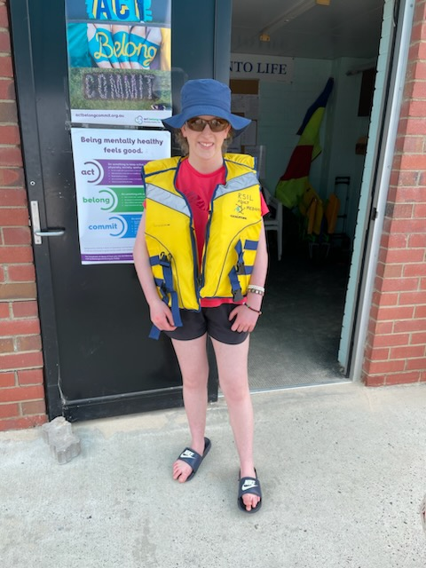

Zoe in front of the Act Belong Commit posters supplied by Healthways a great supporter of Sail Into Life.

**DEMOGRAPHICS**

A total number of 74 participants registered for the 2022/23 program covering a large range of ages.

These people were from Bunbury, Australind, Eaton, Harvey, Kirup and Dalyellup.

The participants belong to eight different organisations, plus private participants.

|  |  |
| --- | --- |
| Enable | 23 |
| Cam Can | 10 |
| St Judes | 2 |
| Activ | 16 |
| My Place | 3 |
| Holmes Vac | 1 |
| Colleen | 8 |
| Schools | 1 |
| Private | 10 |

**FUNDING and FUNDRAISING**

Healthways $10,000

Enable $10,000

Rotary Club of Bunbury $2000

Rotary Club of Bunbury Leschenault $2000

Rotary Club of South Bunbury $2000

City of Bunbury $2500

Sausage Sizzle $1000

**VOLUNTEERS**

Twenty three volunteers gave their time to Sail Into Life. They are very dedicated people who love the program and never hesitate to give extra time when needed.

In appreciation of their work a Christmas function was held at the Koombana Bay Sailing Club. The Sailing club organized a barbecue. Bjorn showed his appreciation for the efforts of the volunteers and suppled drinks..

The new volunteers completed their NDIS certificates and Working With Children Card

Two volunteers are booked to take their skippers ticket. This is required to drive the safety boat and the fishing pontoon.

The new skipper of the fishing pontoon completed a fishing licence

**Volunteers wearing the wide brimmed hats supplied by our generous sponsor Healthways**

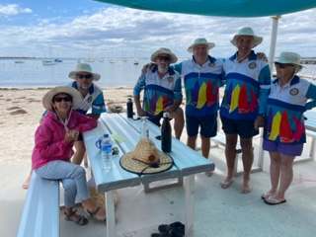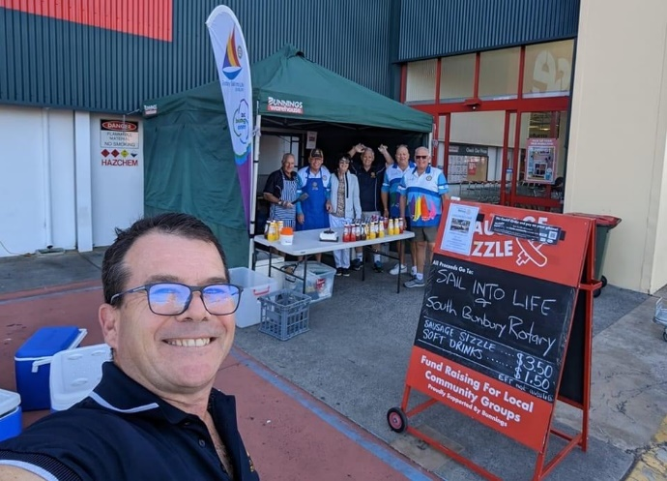

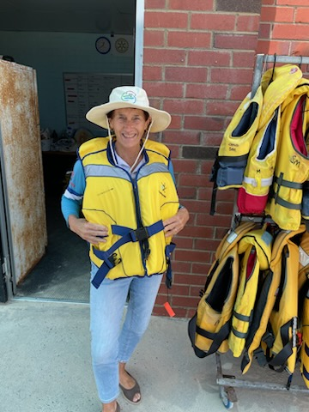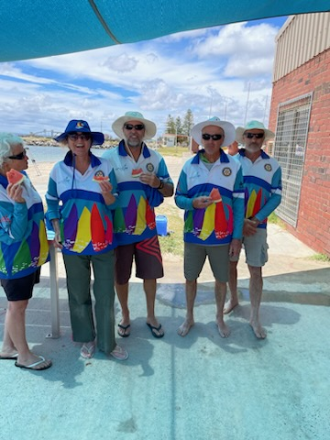

**Vicki modelling the new life jackets donated by the Long Table Lunch and other volunteers enjoying watermelon which is given to all participants daily to encourage healthy eating**

**SAILING**

Allowing Christmas/New Year break and public holidays, out of 40 sailing days, SIL took place on 35 days. Five days were cancelled due to the weather/high winds.

South Bunbury Special Ed participated in sailing on Wednesdays in March/April for a five week period. This was the first school to resume sailing post covid.

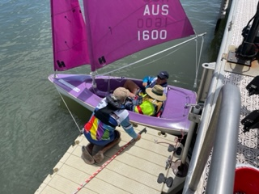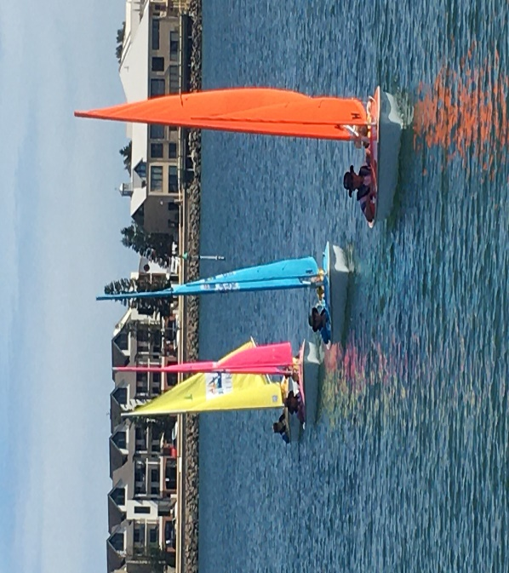

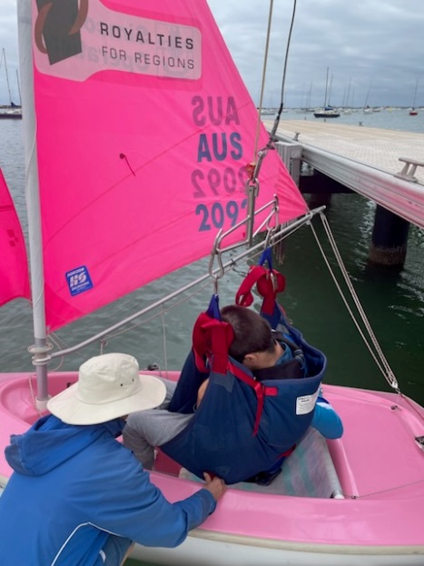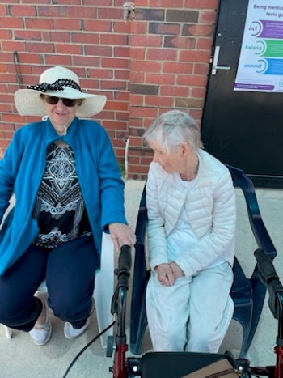

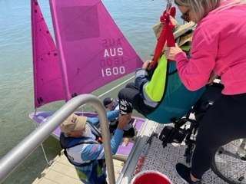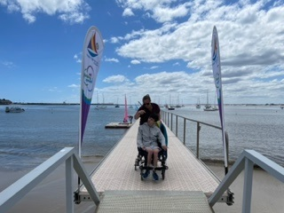

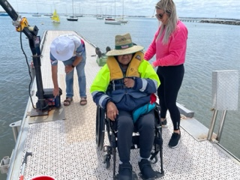

**Healthways banners are displayed each sailing day**

**FISHING**

The two outings program, 9am and 11am for the fishing pontoon on a Wednesday has continued successfully in the 2022/23 year. It continues to be a great source of enjoyment for the participants. Dolphins are a common sight on a Wednesday and this year penguins were sighted. Two Pink Snapper were caught on one occasion which caused much excitement, unfortunately they were too small to be kept but it created a lot of fun..

Peter Hill oversaw the yearly servicing of the fishing pontoon motors. It will be put on stands for the winter to protect it from winds and rough seas.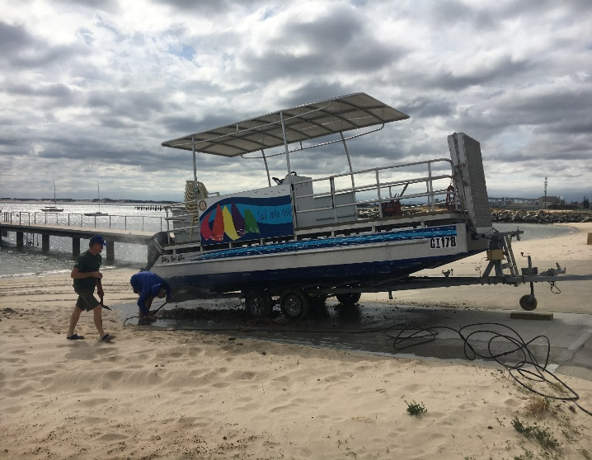

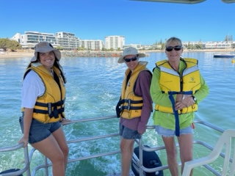

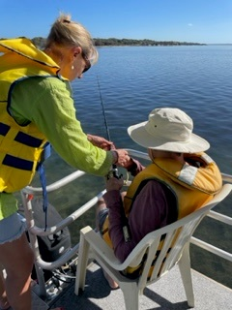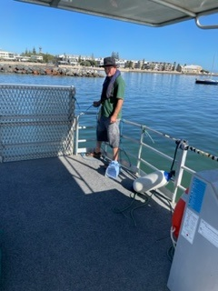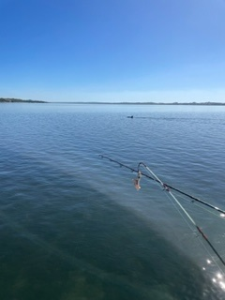Visit from a dolphin

**OVERVIEW**

The season was very successful and brought much enjoyment to all the participants.

We are forever grateful to our sponsors Enable, Healthways, Southern Ports, Chefs Long Table Lunch

City of Bunbury and the Bunbury Rotary Clubs,without their financial support the program would

not run.

More shade is needed for the increasing number of clients, funding will be followed up for this. Permission will have to be given by the Koombana Bay Sailing Club for any structure.

The boats are ageing and will need some fibreglassing this break.

One new sail was purchased this season.

Funding will once again be sought from Enable and Healthways for the 2023/24 season

**CURRENT ASSETS AS AT 30TH JUNE 2023**

|  |  |  |  |  |  |  |  |  |  |  |  |  |  |  |
| --- | --- | --- | --- | --- | --- | --- | --- | --- | --- | --- | --- | --- | --- | --- |
| Assets Rotary Sail into Life | | 2022/23 |  |  |  |  |  |  |  |  | value |  | Value 2022 | |
|  |  |  |  |  |  |  |  |  |  |  |  |  |  |  |
| 2 | 2.3 Hansa Access Dinghies |  |  |  |  |  |  |  |  |  |  |  |  |  |
|  | complete with masts, booms, centre boards, rudders long and short pins, full set of sails | | |  |  |  |  |  |  |  | $28,757 | sold Nov 2022 | | $600 |
| 5 | 303 Hansa access Dinghies |  |  |  |  |  |  |  |  |  |  |  |  |  |
|  | complete with masts, booms, foremast centre boards, rudders long and short pins, full set of sails main  and jib | | | | |  |  |  |  |  |  |  |  |  |
| 1 | spare set of 303 sails main and jib |  |  |  |  |  |  |  |  |  |  |  |  |  |
|  |  |  |  |  |  |  |  |  |  |  | $43,000 |  |  |  |
|  |  |  |  |  |  |  |  |  |  |  |  |  |  |  |
|  |  |  |  |  |  |  |  |  |  |  |  |  |  |  |
| 1 | 5 Hp Suzuki outboard 4 stroke |  |  |  |  |  |  |  |  |  |  |  |  |  |
| 1 | boat trolley |  |  |  |  |  |  |  |  |  |  |  |  |  |
| 1 | Crane Hoist |  |  |  |  |  |  |  |  |  |  |  |  |  |
| 1 | Crane Hoist - Electric |  |  |  |  |  |  |  |  |  |  |  |  |  |
| 5 | Slings for hoist |  |  |  |  |  |  |  |  |  |  |  |  |  |
| 20 | Life vests assorted sizes |  |  |  |  |  |  |  |  |  |  |  |  |  |
| 10 | inflatable life vests |  |  |  |  |  |  |  |  |  |  |  |  |  |
| 3 | portable Floating Pontoon and associated hardware to join to jetty | |  |  |  |  |  |  |  |  |  |  |  |  |
| 1 | Rotary Sail into Life vinyl banner |  |  |  |  |  |  |  |  |  |  |  |  |  |
| 1 | Rotary Sail into life tear drop banner |  |  |  |  |  |  |  |  |  |  |  |  |  |
| 1 | Hansa Keel caddy |  |  |  |  |  |  |  |  |  |  |  |  |  |
| 2 | Hansa 303 access dinghy trolleys |  |  |  |  |  |  |  |  |  | $20,460 |  |  |  |
| 1 | Dinghy & Motor |  |  |  |  |  |  |  |  |  | $7,400 |  |  |  |
| 1 | Fridge freezer |  |  |  |  |  |  |  |  |  | Donated |  |  |  |
| 1 | Jumbuck 4 Burner BBq |  |  |  |  |  |  |  |  |  | $400 |  |  |  |
| 2 | Lockable metal cabinets |  |  |  |  |  |  |  |  |  | $300 |  |  |  |
| 1 | outdoor setting aluminium |  |  |  |  |  |  |  |  |  | $2,000 |  |  |  |
| 1 | Motorised Pontoon |  |  |  |  |  |  |  |  |  | $60,000 |  |  |  |
| 1 | MOBI Mat 10 meters |  |  |  |  |  |  |  |  |  | $3,000 |  |  |  |
| 8 | GX800 radios |  |  |  |  |  |  |  |  |  | $1,720 | 5 purchased 2020 | |  |
| 5 | Blue divider cushions |  |  |  |  |  |  |  |  |  | $175 | 2020 |  |  |
|  |  |  |  |  |  |  |  |  |  |  | $200 | from Healthways | |  |
|  |  |  |  |  |  |  |  |  |  |  | $200 | from Healthways | |  |
|  |  |  |  |  |  |  |  |  |  |  |  |  |  |  |
| 18/10/2018 | Beach Matting |  | $3,730 |  |  |  |  |  |  |  |  |  |  |  |
| 1/11/2018 | Lifting Sling |  | $216.27 |  |  |  |  |  |  |  |  |  |  |  |
| 24/01/2018 | Laptop |  | $878.00 |  |  |  |  |  |  |  |  |  |  |  |
| 17/09/2020 | 5 Radios |  |  |  |  |  |  |  |  |  |  |  |  |  |
| 1/01/2021 | Dinghy Trailer |  | $2,722 |  |  |  |  |  |  |  |  |  |  |  |
| 8/01/2019 | Lifting Crane |  | $594 |  |  |  |  |  |  |  |  |  |  |  |
|  |  |  |  |  |  |  |  |  |  |  |  |  |  |  |
| 17/09/2020 | 5 Radios |  | $930 |  |  |  |  |  |  |  |  |  |  |  |
| Jan-21 | Dinghy Trailers | Southern Ports | $2,722 |  |  |  |  |  |  |  |  |  |  |  |
| Feb-22 | Table suitable for Wheelchairs Plus Benches |  | $2,160 |  |  |  |  |  |  |  |  |  |  |  |
| Feb-22 | Outboard Motor for Rescue Boat | Honda Foundation | $2,380 |  |  |  |  |  |  |  |  |  |  |  |
|  |  |  |  |  |  |  |  |  |  |  |  |  |  |  |
|  |  |  |  |  |  |  |  |  |  |  |  |  |  |  |
| Nov-22 | 15 Life jackets | Long Table lunch | $1,065 |  |  |  |  |  |  |  |  |  |  |  |
| Mar-23 | 4 Radios | Long Table Lunch | $900 |  |  |  |  |  |  |  |  |  |  |  |
| Mar-23 | 3 life jackets | Long Table Lunch | $285 |  |  |  |  |  |  |  |  |  |  |  |
|  |  |  |  |  |  |  |  |  |  |  |  |  |  |  |

Jan 23 Sail for blue dinghy $976.28